**SUBSCRIBERS GALORE; WORLD TOP YOUTUBE CHANNELS**

**INTRODUCTION;**

**1.Overview**

Some world top youtube channels.

1. T-series
2. Cocomelon – nursery rhymes

3.SET INDIA

4.Kids Diana show

5.Like Nastya

6.WWE

7.5-minute crafts

8.Ryan’sworld

9.Pewdiepie

2.**PURPOSE**;

* The purpose of world’s top youtube channels varies depending on the content and the creators behind him

1.**ENTERTAINMENT;**

* Many of these channels such as pewdiepie WWEand smosh ,aim to entertain their audiences throw gaming .comedy sketches,wrestling and others form of entertainment.

2.**EDUCATION AND LEARNING**;

* Channels like cocomelon,kids Diana show andRyan’s worlds focus on entertaining children.

3.**MUSIC PROMOTIONS;**

* T-series as the most subscribed channel ,promotes Indian music and film content

.

**4.DIY AND LIFE HACKS**

* 5-MINUTE CRAFTS AND SIMILAR channels ofer practical tips,diy projects and life hacks.

**5.FAMILY AND LIFESTYLE;**

* Channels like like nastya and holasoygerman feature family vlogs,lifestyle content and relatable experience.

2.**PROBLEM DEFINATION & DESIGN THINGING;**

**2.1 EMPATHY MAP**

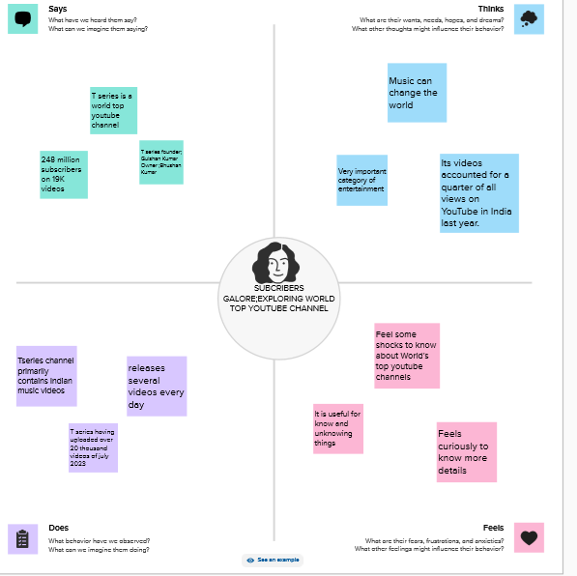

* 1. **IDEATION & BRAINSTORMING MAP**

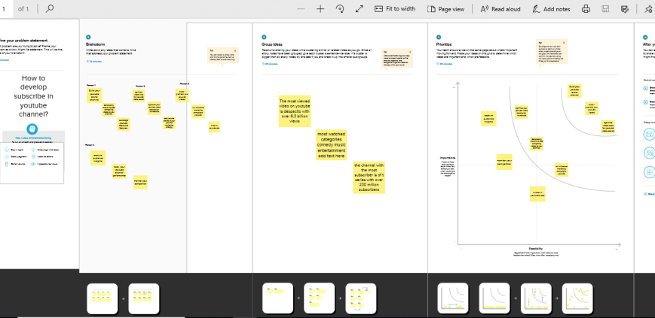

**DASHBOARD 1**

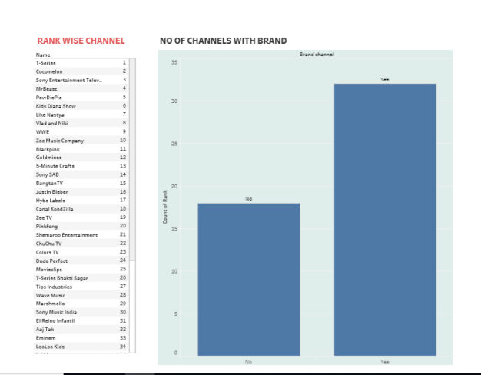

**DASHBOARD 2**

**DASHBOARD 3**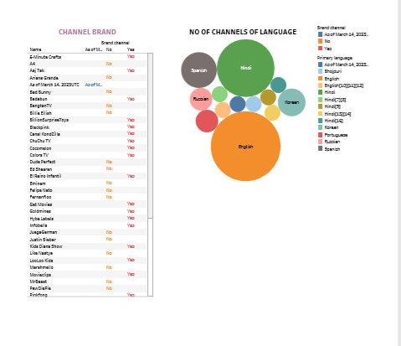

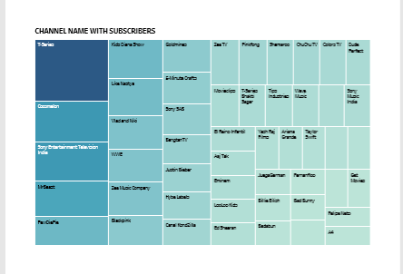

**DASHBOARD 4**

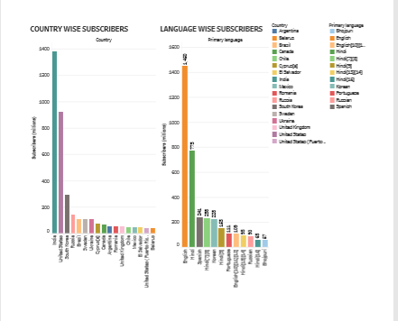

**DASHBOARD 5**

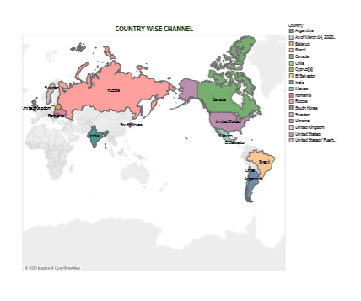

**STORY**

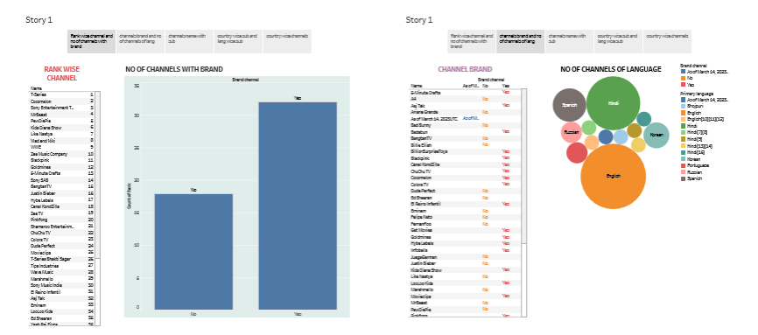

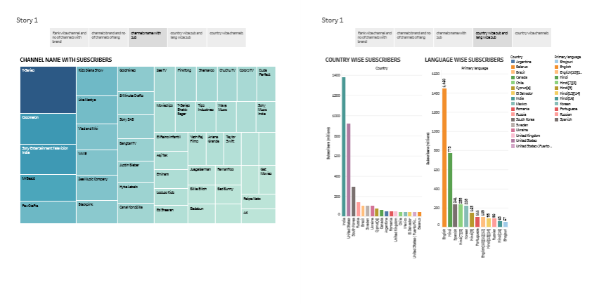

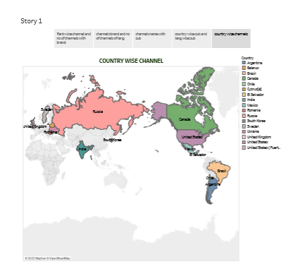

* **ADVANTAGES**

**1.DIVESE CONTENT:**

* Topyoutube channels covers a wide range of topics and genres, allowing viewers to find content the aligns with their intrest , from entertainment and education to life style and gaming.

2.**ENTERTAINMENT AN RELAXATION:**

* These channels provide a source of entertainment and relaxation for viewers.

**3.EDUCATION AND LEARNING:**

* Educational channels like TED-Ed and Vsauce offer valuable knowledge insights on various subjects,making it a platform for continuous learning.
* **DISADVANTAGES:**

**1.TIME CONSUMPTION:**

* Watching YouTube content, especially when bridge watching, can be time-consuming and distracting,potentially affecting productivity and real-life responsibilities.

**2.ADDICTIVE NATURE:**

* The platform’s design,with autoplay and endless suggested videos,can lead to addictive viewing habits,resulting in decreased sleep and other negative effects on well being.
* **CONCLUSION:**
* In conclusion exploring world’s to YouTube channels offers a vast and diverse range of content from entertainment and education to Inspiration and culture exposure. YouTube impact on individuals and society is significant, and by being mindful of both its advantages and disadvantages viewers and creators can make the most of this influential platform while ensuring a safe and positive online experience.

**FUTURE SCOPE:**

**1.USER ENGAGEMENT:**

* Features for user engagement, such as comments, discussion, and community forums can be integrated to facilitate meaningful forms discussion features with shared.

**2.CONTENT DIVERSITY:**

* The platform can continue to expand its catalog to include a brodar spectrum of YouTube channels across different generes , languages,and regions , catering to a more diverse audience.